Department of Electrical and Electronic Engineering

DESIGN AND IMPLEMENTATION OF A FIRE FIGHTING ROBOT

Submitted By -
Jiku Chowdhury
ID:143002720

- Md Jabed Hossain
ID: 143000820

Pulak Barua
ID: 143001020

April, 2017
i

DESIGN AND IMPLEMENTATION OF A FIRE FIGHTING ROBOT

This project is submitted in partial fulfillment of the requirement for the degree of Bachelor of Science in Electrical and Electronic Engineering

by
Jiku Chowdhury
ID:143002720

- Md Jabed Hossain
ID: 143000820

Pulak Barua
ID: 143001020

Supervised by

Mohammad Toufiq Ahamed
Assistant Professor
School of Science Engineering & Technology
East Delta University

Department of Electrical and Electronic Engineering
School of Science Engineering & Technology
East Delta University
Mujaffar Nagor,Chittagong
ii

This project titled “FLEX SENSOR BASED ROBOTIC ARM USING MICRO CONTROLLER” is submitted by ID No. 143003920, 142003620, 142000520, has been accepted as satisfactory in fulfillment of the requirement for the degree of Bachelor of Science in Electrical and Electronic Engineering to be awarded by East Delta University.

Board of Examiners

1.__________________
Dr. Mohammed Nazim Uddin
Associate Dean & Associate Professor Chairman
School of Science Engineering & Technology
East Delta University

2.__________________

External
School of Science Engineering & Technology
East Delta University

3.__________________
Mohammad Toufiq Ahamed
Supervisor
Assistant Professor
School of Science Engineering & Technology
East Delta University

iii

Acknowledgement
During the process of developing this paper, we have received help from our teachers, friends and family which we must acknowledge at the onset. First we are grateful to Allah for helping us to come this far and giving us the strength to complete this project.
We would like to thank our supervisor Sudip Paul. We are extremely grateful and indebted to him for his expert, sincere and valuable guidance. We take this opportunity to record our sincere thanks to all the faculty members of EDU for their help and encouragement.
Our sincere acknowledgement also goes to our parents who have nicely reciprocated our oblivion nature by their nourishing and generous attitude toward us since our childhood.
We also place on record, our gratitude to all who, directly or indirectly, have helped me on this paper.

iv

Abstract

In today’s world there is an increasing need to create artificial limbs for different inhuman situations where human interaction is difficult or impossible. Sensor plays an important role in robotics. Sensors are used to determine the current state of the system. In robotics, sensors with high degrees of repeatability, precision, and reliability are required. We have made flex sensor based robotic hand that looks and works like a man’s hand. We have tried our level best to make a mechanical hand as man’s hand by using flex sensor and micro controller.

v

Table of Contents

The Page Title |  | i-ii
Certificate of Approval |  | iii
Acknowledgment |  | iv
Abstract |  | v
List of figures |  | vi-xii
Chapter – 1

FLEX SENSOR BASED ROBOTIC ARM USING MICRO
CONTROLLER

1.1 | Introduction |  | 1
REQUERMENTS AND OBJECTIVES

1.2 | Aim of This project |  | 1
1.3 | Background |  | 2
1.4 | Objectives |  | 2
1.5 | Software Requirements |  | 2
1.6 | List of Required Components |  | 3
1.7 | Basic Block Diagram |  | 4
1.8 | Subproject |  | 5
1.9 | Organization of the presentation |  | 6

vi

Chapter – 2

FLEX SENSOR

2.1 | Introduction | 7
2.2 | How it works | 8
2.3 | Flex sensor circuit | 9
2.4 | Features | 10
2.5 | Possible uses | 10
2.6 | Applications | 11

Chapter – 3

ARDUINO

3.1 | Introduction | 12
3.2 | Overview | 12-13
3.3 | Summary | 14
3.4 | Power | 14
3.5 | Memory | 14
3.6 | Input and Output | 15
3.7 | Communication | 15
3.8 | Use over current protection | 16

vii

Chapter – 4

SERVO MOTOR

4.1 | Introduction | 17-18
4.2 | Inside the servo motor | 19
4.3 | How servo works | 20
4.4 | Advantages | 21
4.5 | Disadvantages | 21
4.6 | Applications | 22
Chapter – 5

LIOP BATTERY AND BUCK CONVERTER

5.1 | 12V Lipo Battery | 23-24
5.2 | Buck converter | 25-27
Chapter – 6

THE GLOVE

6.1 | History | 28
6.2 | Why use a Glove device | 28
6.3 | What do Glove device measure | 29
6.4 | Working principle of Glove | 29-30

viii

Chapter – 7

ROBOTIC ARM

7 .1 | History | 31
7.2 | Robotic Arm | 31
7.3 | Features of a Robotic Arm | 32
7.4 | Applications | 33
Chapter – 8

DESIGN DETAIL

8.1 | Design method | 34-35
8.2 | Sew the Glove | 36
8.3 | Circuit of project | 37-38
8.4 | Program | 39-41
8.5 | Uses of Robotic Arm | 41
8.6 | The Advantages of Robotic Arm | 41
8.7 | Future of Robotic Arm | 42
8.8 | Summary | 42

ix

Chapter – 9

COST

9.1 | Parts and labor | 43
Chapter – 10

CONCLUSION

10.1 | Successes | 44
10.2 | Uncertainties | 44
Chapter – 11

REFERENCES AND PUBLICATIONS

11.1 | References | 45-46
11.2 | Publications | 46-47

x

List of Figure

Figure No. | Name | Page No.
1.1 | Block Diagram | 4
1.2 | Block Diagram Figure | 5
2.1 | Flex Sensors | 8
2.2 | Flex Sensors | 9
2.3 | Flex Sensor Circuit | 10
3.1 | Arduino UNO | 13
4.1 | Servo Motor | 18
4.2 | Servo Motor | 19
4.3 | Servo Motor Circuit | 20
5.1 | Lipo Battery | 24
5.2 | Buck Converte Circuit  Diagram | 25
5.3 | Buck Converter | 27
6.1 | Glove Device | 29
7.1 | Our Project | 35
8.1 | Circuit of Project | 38

xi

Abbreviations

Short Form | Full Form
AC | Alternating Current
DC | Direct Current
EEPROM | Electrically Erasable Programmable Read Only Memory
IDE | Integrated Drive Electronics
I/O | Input /Output
LED | Light Emitting Diode
MISO | Master in Slave Out
MOSI | Master Out Slave In
PROM | Programmable Read Only Memory
PCB | Printed Circuit Board
REF | Reference
RC | Radio Controlled
RX | Receiver
SCK | Serial Clock
UART | Universal Asynchronous Receiver/Transmitter

xii

CHAPTER – 1

FLEX SENSOR BASED ROBOTIC ARM USING
MICRO CONTROLLER

  - INTRODUCTION

Human gestures are undoubtedly natural. They may often prove more efficient and powerful as compared to various other modes of interaction. The gestures are communicative, meaningful body motions- i.e. physical movement of the fingers, hands, arms, head, face, or body with the objective to convey information or interact with the environment. In our work gesture recognition has been proposed to understand the action of a hand. To increase the use of robots where conditions are not certain such as firefighting or rescue operation we can make robots which follows the instruction of human operator and perform the task, in this way decisions are taken according to the working condition by the operator and task is performed by the robots. Thus we can use these robots to perform those tasks that may be harmful for human beings.

  - AIM OF THIS ROJECT

In future micro controller based programs can be flexibly modified to suit the necessary drive control of the servomotor. In future the project could be modified to be wireless using Bluetooth or RF technology.

1

  - BACKGROUND

The word robot was derived from Czech word Robot which means “a forced labor”. Thus the robot technology is advancing rapidly. Now a day’s the most commonly used robots in industry is robotic hand or a robotic manipulator. Robotic hand is basically kinematics chain of rigid links interconnected by movable joints. The hand is also called end effectors. The end effecter may be a tool or a gripper or any other device to do the work. The end effectors is similar to the human hand with fingers.

  - OBJECTIVES
The main objective of this project is to design microcontroller based robotic hand controlled by hand gesture. The goal of the project is to design a useful and fully functional real-world system that efficiently translates the hand gesture into the movement of the fiber glass made hand. This project is based on the technology to help the deaf community. This could be also further enhanced in various applications such as robotics, automation systems, etc. we have design the hand which moves, forward, backward, left, right and stops based on the gesture of the user. The movement of the robotic hand is done by using servo motors. Key terms: Glove, Flex sensor, microcontroller and servo motor.

  - SOFTWARE REQUIREMENTS

ARDUINO 1.0.5 Compiler is used to write the code and compiling the hex Code.
Proteus Software is used for Circuit Design

2

  - LIST OF REQUIRED COMPONENTS

Categories | Amount
Microcontroller | 1
Servomotors | 5
Flex sensors | 5
PCB plain board | 2
Vero board | 2
Resistors | Various
Jumper wires | Various
Connectors | Various
Fiberglass sheet For Hand | 1
Labor
ARDUINO UNO | 1
Glove | 1
Lipo Battery | 1

Table: 2.1-List of Required Components

3

  - BASIC BLOCK DIAGRAM

The user wears a glove with flex sensor the gesture made by the user is sensed by flex sensor and is given at the microcontroller. This occurs at the transmitter end. The microcontroller processes these signals and encodes it. These signals are transmitted to the receiver end. At the receiver end, the received signal is decoded in the required form and makes the motor run. The basic block diagram of the project as shown below fig: ( 1.1).


Figure (1.1) Block Diagram

4

  - SUBPROJECT

The block diagram in figure (1.2) presents an overview of the entire project.
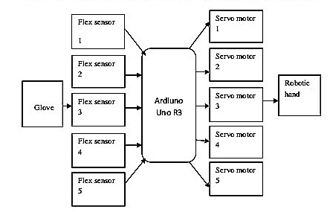
Figure (1.2) Block Diagram

Flex sensor Microcontroller Servo motor Flex sensor 1 Flex sensor 2 Flex sensor 3 Flex sensor 4 Flex sensor 5 Ardiuno Uno R3 Servo motor 1 Servo motor 2 Servo motor 3 Servo motor 4 Servo motor 5 Robotic hand Glove
Figure (1.2) Overview of the entire project The project is divided into five major subprojects as follows:

Glove Design

The design and implementation of a sensor-based glove system that can be worn by the user and comfortably provide stable and accurate control of the robotic hand.

Servo Motor Data Signal Circuits

These circuits take input from the glove sensors and generate appropriate motor control signals based on those inputs.

5

Wired Communication

The robotic hand and gesture device are connected through wired connection.

Sensor Feedback System

Flex sensors are used to provide feedback to the user on alignment, position, and collision detection.

Microcontroller Programming

The microcontroller takes input from the sensor feedback system and generates an appropriate control signals for automated control of the robotic hand.

1.9 ORGANIZATION OF THE PRESENTATION

This presentation report consists of five parts. In part one, the introduction is given the theme of the work is shown. In Part two we have explained each and every component which is required for this project. Part three we describe about the project design detail. And the fourth part consists of expenditure of the project. The part five consists on the overall certainties and uncertainties of the project results.

6

CHAPTER – 2

FLEX SENSOR

2.1 INTRODUCTION

A simple flex sensor is 4.5" in length. As the sensor is bent, the resistance across the sensor increases. Flex sensors are sensors that change in resistance depending on the amount of the bend on the sensor. They are often used in gloves to sense finger movement. Flex sensors are simple in construction. As shown in , they convert the change in bend to electrical resistance the more the bend, the more the resistance value. They are usually in the form of thin strip 1-5 long that vary in resistance. They can be made unidirectional or bi-directional. Resistance v/s degree Flex sensors are passive resistive devices that can be used to detect bending or flexing. The flex sensor shown in this is a bi-directional flex sensor that decreases its resistance in proportion to the amount it is bent in either direction. The sensor we are building is about 3/8" wide by 5" long. The ranges of the flex sensor are 10kΩ to 40kΩ. The Flex sensor offers variable resistance readings, resistance for the un-flexed is 10kΩ and for the flexed the resistance is 40kΩ. Flex sensors are analogue resistors. They work as variable analogue voltage dividers. The flex sensor shown in fig is the unidirectional. Flex sensor is a unique component that changes resistance when flexed. Flex sensor is bent in one direction the resistance gradually increases.

7

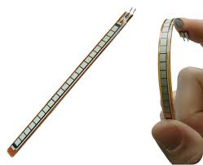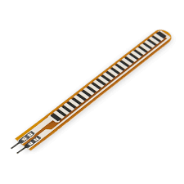

Figure (2.1) FLEX SENSORS

2.2. HOW IT WORKS

Flex sensors are analogue resistors, they works as variable analogue voltage divider. Inside the flex sensors are carbon resistive elements within a thin flexible substrate. More carbon means less resistance, when the substrate is bent the sensor produces a resistance output relative to the bent radius. The higher the resistance value yielding smaller radius. 12. Working of Flex sensor The nominal resistance at 0 degree is 10kΩ, at the bent of 45 degree the resistance will be increased. At 90 degrees will give 30-40 K ohms as shown above. The Bend Sensor lists resistance of 30-250 K ohms and if the flex sensor is further bent the resistance will be further increased. The flex sensor operating temperature is -45F to 125F. The Flex point Bend Sensor is somewhat different from the simple flex sensors. It has a much bigger range of resistance.

8

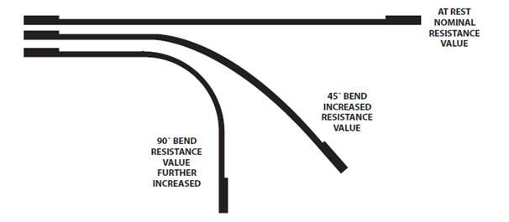
Figure (2.2) FLEX SENSORS

2.3. FLEX SENSOR CIRCUIT

PURPOSE OF VOLTAGE DIVIDER IN FLEX SENSOR The flex sensor changes its resistance when flexed so we can measure that change using one of the Arduino’s analogue pins. But to do that we need a fixed resistor (not changing) that we can use for that comparison (We are using a 22K resistor). This is called a voltage divider and divides the 5V between the flex sensor and the resistor.

9

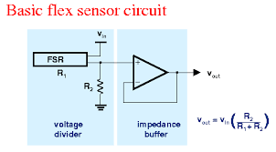
Figure (2.3) FLEX SENSORS CIRCUIT

2.4. FEATURES
1. Angle displacement measurement.
2. Bends and flexes physically with motion device.
3. Helps to provide more accurate data.

2.5. POSSIBLE USES
1. Robotics
2. Gaming (Virtual Motion)
3. Medical devices
4. Computer peripherals
5. Musical instrument.
10

2.6 APPLICATIONS

Flex sensors may be used in robotics to determine joint movement or placement. They may also be used like whiskers for wall detection. The sensors we are making are also pressure sensitive so they can also be used as bumper switches for wall detection or pressure switches on robotic grippers. For bio-metrics, the sensor can be placed on a moving joint of athletic equipment to provide an electrical indication of movement or placement. A few of the sensors can be incorporated onto a glove to make virtual reality glove.

11

CHAPTER – 3

ARDUINO

3.1 Introduction

The only Uno is the latest version after the duemilanove, with an improved USB interface chip. Like the Duemilanove , it not only has an expended shield header with A 3.3V reference and a RESET pin(which solves the problem of how to get to the RESET pin in shield) and a 500ma fuse to protect your computer’s USB port, but also an automatic circuit to select USB or DC power without a jumper. The Uno is pin and code compatible with the duemilanove, diecimilla and older Arduino’s your entire shield, libraries, code will still work. The new R3 (3rd revision) of the UNO has a few minor updates, with an upgrade to the USB interface chip and additional breakouts for the i2c pins and an I/O Ref pin.

3.2 OVERVIEW
Arduino is an open source electronics prototyping platform based on flexible, easy to use hardware and software. It’s intended for artist, designers, hobbyists, and anyone interested in creating interactive object or environment as shown in. The Arduino can sense the environment by receiving input from a variety of sensor and can affect its surroundings by controlling lights, motors, and other actuators. The microcontroller on the board is programmed using the Arduino UNO programming language (based on wiring) and the Arduino development environment (based on processing). Arduino projects can be stand-alone or they can communicate with software running on a computer.

12

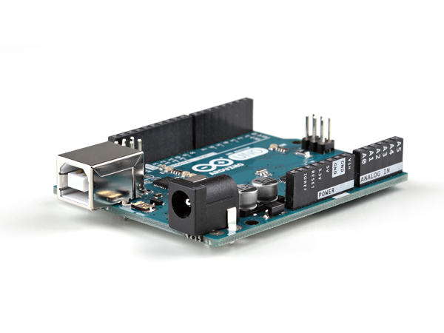

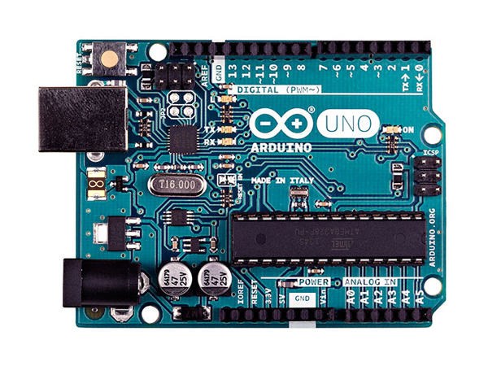
Figure (3.1) ARDUINO UNO

Arduino UNO R3 The board can be built by hand or purchased pre-assembled the software can be download for free.

13

  - SUMMARY

Microcontroller ATmega328
Operating Voltage 5V
Input Voltage (recommended) 7-12V
Input Voltage (limits) 6-20V
Digital I/O Pins 14
Analog Input Pins 6
DC Current per I/O Pin 40Ma
DC Current for 3.3V Pin 50Ma
Flash Memory 32 KB
SRAM 2 KB (ATmega328)
EEPROM 1 KB (ATmega328)
Clock Speed 16 MHz

  - POWER

The Arduino Uno can be powered via the USB connection or with an external power supply. The power source is selected automatically. External (non-USB) power can come either from an AC-to-DC adapter battery. The adapter can be connected by plugging a 2.1mm center-positive plug into the board's power jack. Leads from a battery can be inserted in the Ground and VIN pin headers of the power connector.

  - MEMORY

The ATmega328 has 32 KB (with 0.5 KB used for the boot loader). It also has 2 KB of SRAM and 1 KB of EEPROM (which can be read and written with the EEPROM library).

14

  - INPUT AND OUTPUT

Each of the 14 digital pins on the Uno can be used as an input or output,⎫ using pin mode, digital Write, and digital Read functions. They operate at 5 volts. Each pin can provide or receive a maximum of 40mA and has an internal pull-up resistor (disconnected by default) of 20-50 ohms. In addition, some pins have specialized functions: Serial: 0 (RX) and 1 (TX). Used to receive (RX) and transmit (TX) TTL⎫ serial data.
These pins are connected to the corresponding pins of the ATmega8U2 USB-to-TTL Serial chip. External Interrupts: 2 and 3. These pins can be configured to trigger an⎫ interrupt on a low value, a rising or falling edge, or a change in value. See the attach Interrupt () function for details. PWM: 3, 5, 6, 9, 10, and 11. Provide 8-bit PWM output with the analog Write⎫ () function. SPI: 10 (SS), 11 (MOSI), 12 (MISO), 13 (SCK). These pins support SPI⎫ communication using the SPI library. LED: 13. There is a built-in LED connected to digital pin 13. When the pin is⎫ HIGH value, the LED is on, when the pin is LOW, it's off. The Uno has 6 analog inputs, labeled A0 through A5, each of which provide⎫ 10 bits of resolution (i.e. 1024 different values). By default they measure from ground to 5 volts, though is it possible to change the upper end of their range using the AREF pin and the analog Reference () function. Additionally, some pins have specialized functionality. AREF. Reference voltage for the analog inputs. Used with ref ().Reset Bring⎫ this line LOW to reset the microcontroller. Typically used to add a reset button to shield which block the one on the board.

  - COMMUNICATION

The Arduino Uno has a number of facilities for communicating with a computer, another Arduino, or other microcontrollers. The ATmega328 provides UART TTL (5V) serial communication, which is available on digital pins 0 (RX) and 1 (TX). An ATmega16U2 on the board channels this serial communication over USB and appears as a virtual com port to software on the computer.

15

The '16U2 firmware uses the standard USB COM drivers, and no external driver is needed. However, on Windows, a .inf file is required. The Arduino software includes a serial monitor which allows simple textual data to be sent to and from the Arduino board. The RX and TX LEDs on the board will flash when data is being transmitted via the USB-to-serial chip and USB connection to the computer (but not for serial communication on pins 0 and 1). A Software Serial library allows for serial communication on any of the Uno's digital pins. The ATmega328 also supports I2C (TWI) and SPI communication. The Arduino software includes a Wire library to simplify use of the I2C bus.

  - USB OVER CURRENT PROTECTION

The Arduino Uno has a reset table poly-fuse that protects your computer's USB ports from shorts and over current. Although most computers provide their own internal protection, the fuse provides an extra layer of protection. If more than 500mA is applied to the USB port, the fuse will automatically break the connection until the short or overload is removed. 3.9 PHYSICAL CHARACTERISTICS The maximum length and width of the Uno PCB are 2.7 and 2.1 inches respectively, with the USB connector and power jack extending beyond the former dimension. Four screw holes allow the board to be attached to a surface or case. Note that the distance between digital pins 7 and 8 is 160mil (0.16"), not an even multiple of the 100mil spacing of the other pins.

16

CHAPTER – 4

SERVO MOTOR

4.1 INTRODUCTION

Servo refers to an error sensing feedback control which is used to correct the performance of a system. A servo motor consists of three major parts: a motor, control board, and potentiometer (variable resistor) connected to output shaft. The motor utilizes a set of gears to rotate the potentiometer and the output shaft at the same time. The potentiometer, which controls the angle of the servo motor, allows the control circuitry to monitor the current angle of the servo motor. The motor, through a series of gears, turns the output shaft and the potentiometer simultaneously. The potentiometer is fed into the servo control circuit and when the control circuit detects that the position is correct, it stops the servo motor. If the control circuit detects that the angle is not correct, it will turn the servo motor in the right direction until the angle is correct. Servo or RC Servo Motors are DC motors equipped with a servo mechanism for precise control of angular position. The RC servo motors usually have a rotation limit from 90° to 180°. But servos do not rotate continually. Their rotation is restricted in between the fixed angles. Servo motors are shown in and Servo motor Servo motors have been around for a long time and are utilized in many applications. They are small in size but pack a big punch and are very energy-efficient. Because of These features, they can be used to operate remote-controlled or radio-controlled toy cars, robots and airplanes as shown. Servo motors are used in industrial applications. Servos are extremely useful in robotics and automation. Servo motors are used across various automation fields specifically where the motor must be able to operate at a range of speeds without overheating, operate at zero speed while being able to retain its load in a set position, as well as operate at low speeds.

17

Robots utilize servo motors because of their smooth commutation and accurate positioning. The aerospace industry makes use of servo motors in their hydraulic systems to contain system hydraulic fluid.

The servo motor is relatively small in size, yet very powerful. The Servos are used for precision positioning. They are used in robotic arms and legs, sensor scanners and in RC toys like RC helicopter shown in airplanes and cars as shown in Servo motors used in RC helicopter Servo motor used in RC airplanes.

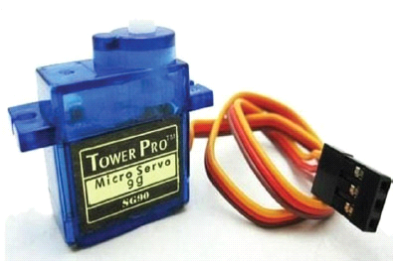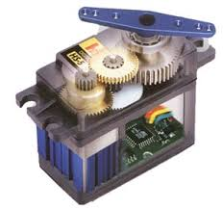

Figure (4.1) SERVO MOTOR

18

4.2 INSIDE THE SERVO MOTOR

To fully understand how the servo works, you need to take a look under the hood. Inside there is a pretty simple set-up a small DC motor, potentiometer and a control circuit. The motor is attached by gears to the control wheel. As the motor rotates, the potentiometer's resistance changes, so the control circuit can precisely regulate how much movement there is and in which direction.
When the shaft of the motor is at the desired position, power supplied to the motor is stopped. If not, the motor is turned in the appropriate direction. The desired position is sent via electrical pulses through the signal wire. The motor's speed is proportional to the difference between its actual position and desired position. So if the motor is near the desired position, it will turn slowly, otherwise it will turn fast. This is called proportional control. The internal construction of servo is shown in Construction of servo motor.

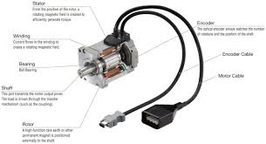

Figure (4.2) SERVO MOTOR
19

4.3 HOW SERVO WORKS

shows the circuit diagram of the servomotor built out of five resistors and a capacitor, aided by a transistor. The power and control are given as input to this circuit. Circuit diagram of servo motor Figure (4.3 b) Angle positioning depends on the length of the pulse.

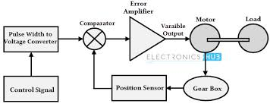

Figure (4.3) SERVO MOTOR

20

4.4 ADVANTAGES

1. High speed and high torque is needed
2. Servo motors also maintain their torque rating at high speed, up to 90% of the rated torque is available from a servo at high speed.
3. Servo motors are quite, available in AC and DC drive, and do not vibrate or suffer from resonance issues.
4. Servo motors usually have a small size.
5. Servo motors have a large angular force (torque) comparing to their size.
6. Servo motors operate in a closed loop, and therefore are very accurate.
7. Servo motors are electrically efficient.

4.5 DISADVANTAGES
1. Servo motors are capable of delivering more power than stepper.
2. Servo motors are also much more expensive than stepper motor.
3. Servo motors often require gear boxes, especially for lower speed operation.
4. The requirement for a gearbox and position encoder make servo motor designs more mechanically complex and increase the maintenance requirements for the system.

21

4.6 APPLICATIONS
Servos are extremely useful in robotics and automation. Servo motors are used across various automation fields specifically where the motor must be able to operate at a range of speeds without overheating, operate at zero speed while being able to retain its load in a set position, as well as operate at low speeds. Robots utilize servo motors because of their smooth commutation and accurate positioning. The aerospace industry makes use of servo motors in their hydraulic systems to contain system hydraulic fluid. The servo motor is relatively small in size, yet very powerful. The Servos are used for precision positioning. They are used in robotic arms and legs, sensor scanners and in RC toys like RC helicopter, airplanes and cars. Servo motors are small, have built-in control circuitry and have good power for their size.

22

CHAPTER – 5

LIPO BATTERY AND BUCK CONVERTER

  - 12V LIPO BATTERY
When talking about a LiPo, the primary characteristics to understand are the battery’s voltage and capacity. This is typically noted in a shorthand such as “4S-2200”. In this example, “4S” denotes that the battery has four cells in series. The nominal voltage of each cell is 3.7 volts (4.2v fully-charged), so the total pack voltage is:
4 cells x 3.7v = 14.8v.
When talking about a LiPo battery, the primary characteristics to understand are the battery’s voltage, capacity, and discharge rate.
The second number denotes the capacity of the battery in milliamp-hours (mAh). A fully charged 2200mAh pack is rated to provide a current of 2200 milliamps (2.2 amps) for one hour before it is fully discharged. This capacity value is completely independent of how many cells are in series. In simple terms, the capacity value allows you to estimate how long a battery will provide useful power in a given application. In practical terms for RC use, the capacity rating is typically only helpful for rough comparisons of different batteries. i.e. a 2S-5000 battery will provide about double the run time of a 2S-2500 lipo in the same RC car.

23

While it was quite common 10 years ago, is now rare to find a RC LiPo battery that uses cells in parallel. Let’s look at an example in case you happen across one. A 4S2P-2200 battery would consist of two 4S-1100 batteries wired in parallel to provide a total 2200mAh capacity. All other things being equal, you would care for and use this battery the same as you would the previous 4S-2200 example (which is really a 4S1P-2200, but we ignore the 1P). There may be a difference in physical size, but a 4S-2200 and a 4S2P-2200 are functionally equivalent.

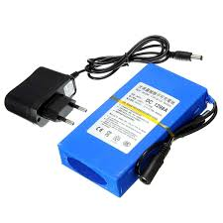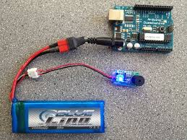
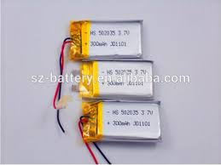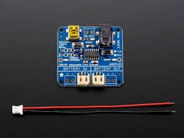
Figure (5.1) LIPO BATTERY
24

5.2 BACK CONVERTER
A buck converter (step-down converter) is a DC-to-DC power converter which steps down voltage (while stepping up current) from its input (supply) to its output (load). It is a class of switched-mode power supply (SMPS) typically containing at least two semiconductors (a diode and a transistor, although modern buck converters frequently replace the diode with a second transistor used for synchronous rectification) and at least one energy storage element, a capacitor, inductor, or the two in combination. To reduce voltage ripple, filters made of capacitors (sometimes in combination with inductors) are normally added to such a converter's output (load-side filter) and input (supply-side filter).^{[1]}
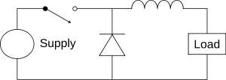

Figure (5.2) BACK CONVERTER CIRCUTI DIAGRAM
Switching converters (such as buck converters) provide much greater power efficiency as DC-to-DC converters than linear regulators, which are simpler circuits that lower voltages by dissipating power as heat, but do not step up output current.
Buck converters can be remarkably efficient (often higher than 90%), making them useful for tasks such as converting a computer's main (bulk) supply voltage (often 12V) down to lower voltages needed by USB, DRAM, the CPU (1.8V or less)

25

The conceptual model of the buck converter is best understood in terms of the relation between current and voltage of the inductor. Beginning with the switch open (off-state), the current in the circuit is zero. When the switch is first closed (on-state), the current will begin to increase, and the inductor will produce an opposing voltage across its terminals in response to the changing current. This voltage drop counteracts the voltage of the source and therefore reduces the net voltage across the load. Over time, the rate of change of current decreases, and the voltage across the inductor also then decreases, increasing the voltage at the load. During this time, the inductor stores energy in the form of a magnetic field. If the switch is opened while the current is still changing, then there will always be a voltage drop across the inductor, so the net voltage at the load will always be less than the input voltage source. When the switch is opened again (off-state), the voltage source will be removed from the circuit, and the current will decrease. The decreasing current will produce a voltage drop across the inductor (opposite to the drop at on-state), and now the inductor becomes a Current Source. The stored energy in the inductor's magnetic field supports the current flow through the load. This current, flowing while the input voltage source is disconnected, when concatenated with the current flowing during on-state, totals to current greater than the average input current (being zero during off-state). The "increase" in average current makes up for the reduction in voltage, and ideally preserves the power provided to the load. During the off-state, the inductor is discharging its stored energy into the rest of the circuit. If the switch is closed again before the inductor fully discharges (on-state), the voltage at the load will always be greater than zero.

26

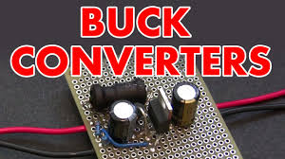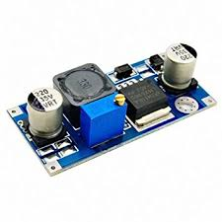
Figure (5.3) BUCK CONVERTER

27

CHAPTER - 6
THE GLOVE

  - HISTORY

First glove like device (cloth) onto which numerous touches bend and inertial sensors were sewn. Measured flexure, hand orientation and wrist-position, and hand tactile sensors are at fingertips. Orientation of hand tracked by video camera required clear line of sight observation for the glove to function. Finger flex sensors, tactile sensor at the fingertips, orientation sensing and wrist positioning sensors, position of sensors were changeable.

  - WHY USE A GLOVE DEVICE

Traditional data input device have a limited range of the amount of data they can input at a given time because they are limited to one, two or three degrees of freedom. Degrees of freedom are measure of the number of position of which the device can be read as inputting a different data values. Gloves offer for superior data input potential since they provide multiple degrees of freedom for each finger and the hand as a whole. By taking orientation of fingers and relative position of hand, glove devices can track an enormous variety of gestures each of which corresponds to a different type of data entry. This gives the glove remarkably rich expressive power, which can be used in the inputting of extremely complicated data.

28

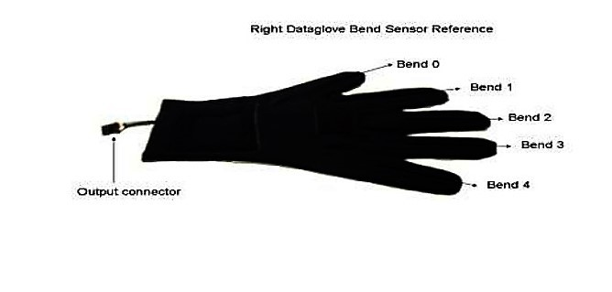
Figure (6.1) GLOVE DEVICE

6.3 WHAT DO GLOVE DEVICES MEASURE
Measure finger flexure and hand orientation, to a greater are lesser extent. Each type of glove measure either four or five fingers (the pinky finger is sometimes excluded) for the degree of flexure, measurement range from the fingers being extended straight in the line with the palm, to being curled up against the palm as in making a first. Glove can track hand orientation by measuring roll, pitch and yaw or position of the hand as a whole.

6.4 WORKING PRINCIPLE OF GLOVE
All data glove devices track the orientation of the hand and fingers using either fiber optics, ultrasonic.
29

However any glove device feed data about hand and finger positions to a tracker, a piece of equipment that process the data so that it can be understood by the computer. The computer then matches the orientation to a file of gestures and fires an event corresponding to the matching gestures.

30

CHAPTER – 7

ROBOTIC ARM

  - HISTORY

The first robotic arm was developed in the 1950s by a scientist named George Devil, Jr., before which robotics were largely the product of science fiction and the imagination. The development of robotics was slow for a while, with many of the most useful applications being involved with space exploration. The use of robots to aid in industrialization weren’t fully realized until the 1980s, when robotic arm began to be integrated in automobile and other manufacturing assembly lines.

7.2 ROBOTIC ARM

A robotic arm can be any of a number of mechanical, programmable devices that are designed to manipulate objects in a way that is similar to the human arm. The robotic hand is one of the most useful pieces of technology to be introduced in the 20th century, and quickly became a cornerstone in many areas of manufacturing. It can be used for many different jobs and functions that may be too tedious, difficult or dangerous for a human to do. You might first think of the automobile industry when thinking about robotic hand, but they can be used for many other useful tasks besides welding and painting auto parts. Robot hand can still have a much wider range of motion since their design can be purely up to the imagination of their creator. The joint that connects the segments of a robotic hand, for example, can rotate as well as moving like a hinge.

31

The end of the robotic arm designed to actually do the work that it was designed for is known as the end effectors, and can be designed for practically any task, for example gripping like a arm, painting, tightening screws and more. These robots can be fixed in one place, for example along an assembly line, or they can be mobile so they can be transported to do a variety of tasks in different places.

Autonomous robotic arm are designed to be programmed and then left alone to repeat their tasks independent of human control. Conversely, a robotic arm can also be designed to be operated and controlled by a human being. A situation where human-controlled robotic arm are essential is in space exploration, where robotic arm can be used to manipulate a heavy payload or do other work in space that would be difficult or even impossible for an astronaut to do. The arm itself is only responsible for positioning. An end effecter is necessary for actual environmental interaction. Some common choices are grippers, sprayers, grinders, welders, and vacuums, though many other options are available. There is a large variance in complexity, ranging from flush mounted, non-moving parts (magnets or sticky pads) to multi-jointed, multi-sensor parts with various inputs and outputs. End effectors are typically chosen based upon the application, and many hands will fit multiple end effectors.

  - FEATURES OF A ROBOTIC ARM

Some robots are programmed to faithfully carry out specific actions over and over again (repetitive actions) without variation and with a high degree of accuracy. These that robot actions are determined by programmed routines that specify the direction, acceleration, velocity, deceleration, and distance of a series of coordinated motions.

32

Other robots are much more flexible as to the orientation of the object on which they are operating or even the task that has to be performed on the object itself, which the robot may even need to identify. For example, for more precise guidance, robots often contain machine vision sub-systems acting as their "eyes", linked to powerful computers or controllers. Artificial intelligence, or what passes for it, is becoming an increasingly important factor in the modern industrial robot.

Most robots are programmed, so we can easily change the program depend the use of that robot. For the employee robot is the ideal workers because they don’t need rest, laugh, sick, food and drink and can minimize the cost significantly for the long term. And the productivity is constant.

  - APPLICATIONS

Robotic arms are typically used in industry. Repetitive autonomous robots perform one task repeatedly based upon predetermined movements and specifically located objects. Start and stop commands are determined by position, acceleration, deceleration, distance, and direction. More complex actions are executed based upon sensor processing. If object orientation or position is unknown, arms are often paired with machine vision and artificial intelligence to identify the object and subsequently control the arm.

33

CHAPTER – 8

DESIGN DETAIL

  - DESIGN METHOD

The basic components of the glove are the hand itself, the servos, the Arduino, the glove and the flex sensors. The glove is mounted with flex sensors variable resistors that change their value when bent they’re attached to one side of voltage divider with resistor of a constant value on the other side. The Arduino reads the voltage change when the sensors are bent, and triggers the servos to move a proportional amount.

34

Making flex sensor circuit

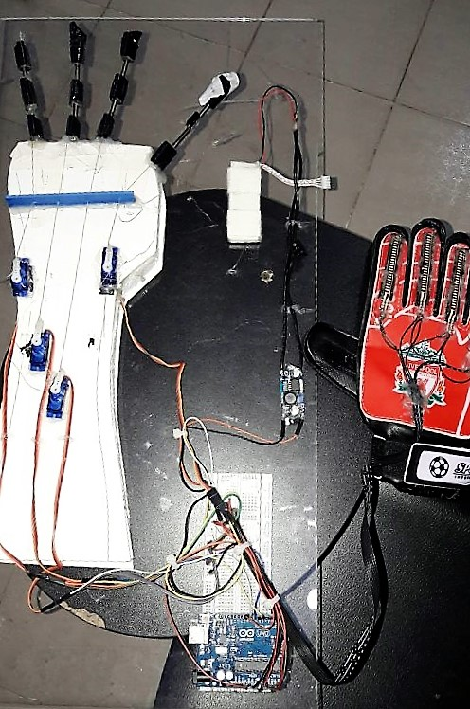

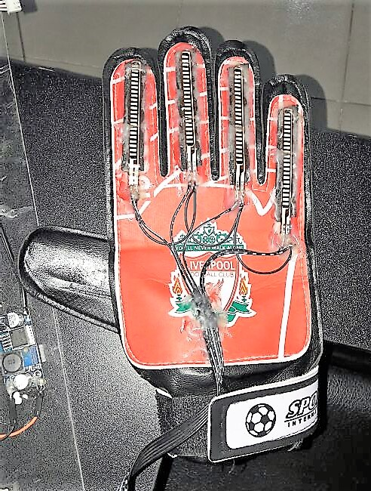

Figure (7.1) OUR PROJECT
35

Circuit design The flex sensors require a circuit in order for them to be compatible with Arduino. It's a voltage divider: the flex sensors are variable resistors, and when paired with resistors of a static value, change in resistance (in this case bending the sensor) can be sensed through the change in voltage between the resistors. This can be measured by the Arduino through its analog inputs. The schematic is attached (red is positive voltage, black is negative, and blue goes to the Arduino). The resistors in the photo are 22KΩ. I color-coded the wires I used in the same way as the schematic, so you can see more easily in figure (8.1). The main GND wire is connected to all the individual GND wires from the sensors gets plugged into the Arduino’s GND. The +5V from wire, and each blue wire gets plugged into a separate analog input pin.

  - SEW THE GLOVE

After making the flex sensor circuit the next part of the project is sew the glove, first of all take the needle and thread, and mount the sensor and circuit onto the glove itself, drill the tiny hole in the plastic of the sensor(at the top, once the resistive material has ended). Be sure does not hit the resistive material then put on the glove and pull it tightly in the hand, on each finger, with a pencil or pen, make small lines over the tops of each joint. This tells where to sew the sensors, sew each sensor tip to the area of each finger just above where is each fingernail.

36

  - CIRCUIT OF PROJECT

In our project we have used 5V for Arduino and same current used from Arduino to flex sensors. For Servo Motors we used extra Power from battery then we used circuit to connect Sensors and Motors to Arduino. Circuit is designed in a very compact manner, so that no or less wires are used and shown with 100% portability. First of all we connected 5V and passed it through resistor of 22k and then attached analog Signal Sender wire on one side connected to flex sensor and on other side ground. In similar way, all 5 sensors are connected to Arduino. Analogue Reading is attached from pins A0 - A4 with each of 5 sensors. Servo Motors are then attached to power and ground through battery and each of them are connected to digital pins from 3-7. Flex Sensors send analog input to Arduino then Arduino converts them to digital reading and sends these readings to digital pins which make Servo Motors to move as Human Fingers move.
But this all hardware work does not make the system functional until it needs some sort of instructions to do so; we made a program and uploaded it.

37

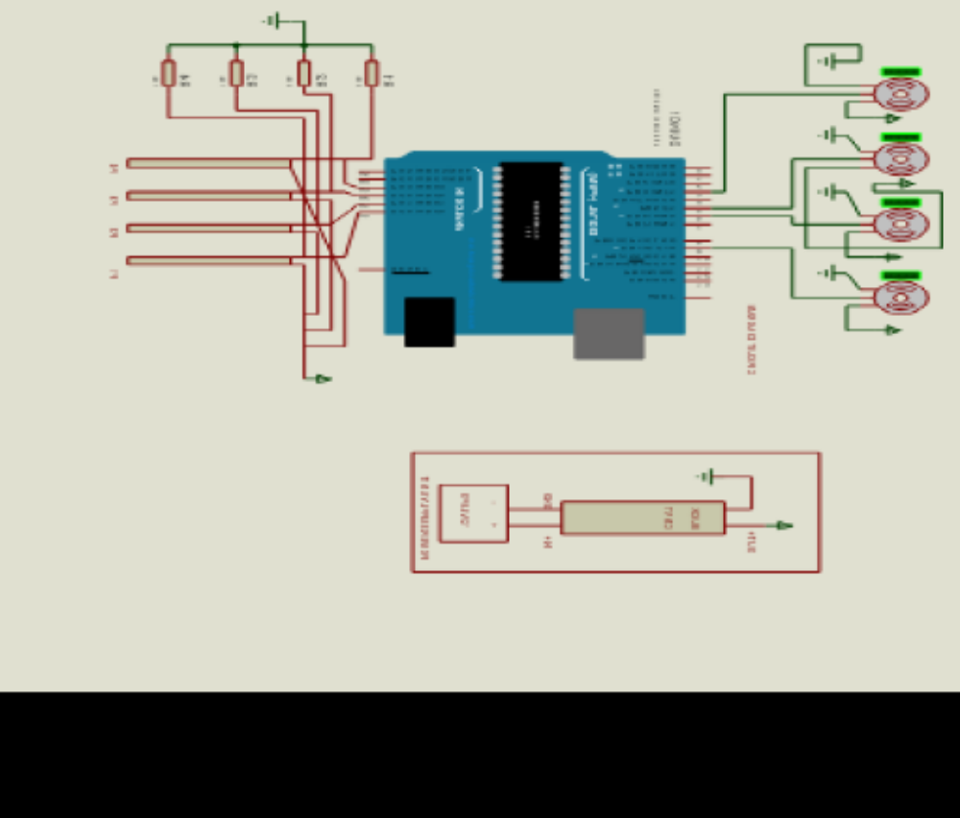

Figure (8.1) CIRCUIT OF PROJECT

38

  - PROGRAM

<--- Start of Program --->

#include<servo.h>//including library file for servo motors.

Servo myservo;//variables defined for servo motors 1-5

Servo myservo1;

Servo myservo2;

Servo myservo3;

Servo myservo4;

/ /Setup of serial for sensors. Setup to attach digital pins to each servo motor.

Void setup(){

Serial.begin(600);

myservo.attach(7);

myservo1.attach(4);

myservo2.attach(5);

myservo3.attach(4);

myservo4.attach(3);}

39

//This area read again and by arduino unless detached from power.
void loop(){

int flexsensorReading = analogRead(A4);// variables defined to take reading from sensors.

int flexsensorReading1=analogRead(A3);

int flexsensorReading2=analogRead(A2);

int flexsensorReading3=analogRead(A1);

int flexsensorReading4=analogRead(A0);

// Map readings first e.g. (sensor Reading, from low,from high, to low, to high);

int val = map(flexsensorReading, 500, 1000, 0, 1000 );

int val = map(flexsensorReading1, 512, 1000, 0, 1023);

int val = map(flexsensorReading2, 512, 100, 0, 1023);

int val = map(flexsensorReading3, 512, 1000, 0, 1023);

int val = map(flexsensorReading4, 512, 1000, 0, 1023);

//Final step is to send readings to digital pins for servo motors to move.

myservo.write(val);

myservo1.write(val1);

40

myservo2.write(val2);

myservo3.write(val3);

myservo4.write(val4);}

<--- End of Program --->

  - USAGE OF ROBOTIC ARM

The robotic arm can be designed to perform any desired task such as welding, gripping, spinning etc., depending on the application. For example robot arm in auto motive assembly lines perform a variety of tasks such as welding and parts rotation and placement during assembly. In some circumstances, close emulation of the human arm is desired, as in robots designed to conduct bomb disarmament and disposal.

8.6 THE ADVANTAGES OF ROBOTIC ARM

Quality

Robotic arms have the capacity to dramatically improve product quality. Applications are performed with precision and high repeatability every time. This level of consistency can be arm to achieve any other way.

Safety

Robotic arms increase workplace safety. Workers are moved to supervisory roles where they no longer have to perform dangerous applications in hazardous settings.

41

Savings

Improved safety leads to financial savings. There are fewer healthcare and insurance concerns for employers. Robotic arms also offer untiring performance which saves valuable time. Their movements are always exact, minimizing material waste.

Production

With robots, throughput speeds increase, which directly impacts production. Because an automated robot has the ability to work at a constant speed without pausing for breaks, sleeps, vacations, it has the potential to produce more than a human worker.

  - FUTURE OF ROBOTIC ARM

We will work on this project in future and make it accessible for all those needy and disabled persons who cannot afford costly Robotic Hand/Arm. Further robotic arm will be made for dangerous things when it will be wireless and can be used from far places without hindrance.
Now, Sensors are used for moving fingers afterwards we will make it auto for all those works which need not variable instructions. Another form of this hand will be access from software wirelessly without sensors which will reduce cost as well.

  - SUMMARY

This is a fun project with many potential applications. Interactive robot control of this level, I think, has many uses in industrial manufacturing, medical research, and anything you want to be able to do with precision that is unsafe to touch.

42

CHAPTER – 9

COST

9.1 PARTS AND LABOR
A detailed cost analysis is shown in Table 9.1.
Categories | Amount | Price
Microcontroller | 1 | BDT 4000
Servomotors | 5 | BDT 10000
Flex sensors | 5 | BDT 25000
PCB plain board | 2 | BDT 400
Vero board | 2 | BDT 400
Resistors | Various | BDT 100
Jumper wires | Various | BDT 400
Connectors | Various | BDT 300
Fiberglass sheet For Hand | 1 | BDT 200
Labor |  | BDT 10000
Glove | 1 | BDT 200
Lipo Battery | 1 | BDT 1500
 | TOTAL COST | = BDT 52100
Table (9.1) Detailed Cost analysis
43

CHAPTER – 10
CONCLUSION

10.1 SUCCESSES

The overall system performs reasonably well. The user is able to carry out comfortable and precise functions of the robotic arm through the use of a sensor based control glove. Furthermore, the robotic arm is capable to carry normal routine function as human arm does. The microcontroller accepts inputs from the sensor and generates the proper control signals based on those inputs.

10.2 UNCERTAINTIES

The lift-capacity of the servo motors on the robotic Hand is limited. Replacement of the current servos with a higher torque model would allow a complete range of motion when manipulating heavier objects. The usable lifetime of the flex sensors seems to be limited. The sensors themselves are very fragile and easily wear out from overuse. Careful maintenance and protection of the flex sensors is crucial to successful operation of the system.

44

CHAPTER – 11

REFERENCES AND PUBLICATIONS

11.1 REFERENCES
www.sparkfun.com
www.slideshare.com
www.ciruictsathome.com
www.instructable.com
www.engineergaurage.com
www.servocity.com
www.hitec.com
www.microchips.com
www.wikipedia.com
www.definition.com
45

www.google.com
www.societyofrobot.com
www.arduino.cc
www.buildtronics.com

11.2 PUBLICATIONS

[1] C. Edwards and E. Smith, “Design of Simulink-Based 2- DOF Robot Arm Control Workstation,” 31 October 2006.
[2] E. Foxl and L. Naimark, “Vis-Tracker: A Wearable Vision-Inertial Self-Tracker,” IEEE Virtual Reality Conference, 22-26 March 2003, Los Angeles.
[3] D. Fontaine, D. David and Y. Caritu, “Sourceless Human Body Motion Capture,” Smart Objects Conference (SOC 2003), Grenoble, 2003.
[4] Journal of Software Engineering and Applications, 2012, 5, 364-366 http://dx.doi.org/10.4236/jsea.2012.5504 Published Online May2012.
[5] J. Bernstein, H. R. Everett, L. Feng, and D. Wehe, “Mo-bile Robot Positioning Sensors & Techniques,” Journal of Robotic Systems, Special Issue on Mobile Robots, Vol. 14, No. 4, pp. 231-249.

46

[6] International Journal of Advanced Research in Electronics and Communication Engineering (IJARECE) Volume 4, Issue 12, December 2015.
[7] M.R. Cutkosky, "On Grasp Choice, Grasp Models, and the Design of Hands for Manufacturing," IEEE Transactions on Robotics and Automation. Vol. 5, pp. 269-279, 1989.
[8] Frequently Asked Questions,” Arduino, (19 July 2014).

[9] Arduino Uno-R3,” Sparkfun, (19 July 2014).

[10] What’s A Servo?,” Seattle Robotics Society, (19 July 2014).

47

